PHOTOGRAPHERS OF DRIPPING SPRINGS
December 13, 2019 –Christmas Party Notes
Location: The Episcopal Church of the Holy Spirit
301 Hays Country Acres Rd

Start time: 6:30 pm

People in attendance – a sizeable bunch (50 or so) Members, friends, and family

PODS President Warren Capps kicked off the evening festivities and all thanked Dee and Tim Kasberger for their hard and good work putting the party together.

Agenda

- Welcome
- “Ode to Warren” written by Patty Robertson and sung by all assembled

“Ode to Warren (Warn)”
(Sung to the tune of the Beverly Hillbilly’s TV Theme Song)

Come and listen to a story ‘bout a man named Warn
A PODS President, who was known for a yarn,
Then one day he was shooting in the dark,
And down to the ground his cam’ra fell with a bark
Olympus that is, mirrorless baby, light as a flea.
Well the first thing you know Old Warn’s got his spare,
PODS folk said Warn! - don’t you despair
Said Precision is the place you ought to be
So he loaded up his truck after prayin’ on a knee.
For a repair, that is.
Quick and cheap
Well now its time to say bye to Warn as our Chief
And we would like to thank him for all of his idee-s.
Now, You're all invited back again to this locality
To have a heapin’ helpin’ of our hospitality
PODS that is. Set a spell. Take your caps off.
Y'all come back now, y'hear?

- Dee’s Famous “Who am I?” game (the name of a famous person ispinned to each person’s back – the person can ask Yes or No questions to figure out who they are)
- Food time – Taco Bar and assorted wonderful goodies and Tom D’s Hot Spiced Cider
- Gift Exchange- White Elephant Yee Haw

ALL IN ALL, ANOTHER FUN PODS CHRITMAS PARTY – JUST ROWDY ENOUGH.

The party ended at approximately 9:00pm.

Submitted Approved
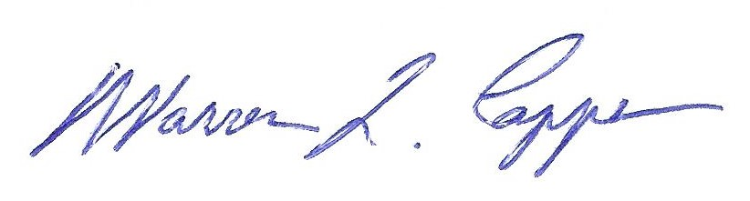

Tim H Graves, Secretary Warren Capps, President

