PHOTOGRAPHERS OF DRIPPING SPRINGS
November 20, 2019 - Monthly Meeting Minutes
Location: The Episcopal Church of the Holy Spirit
301 Hays Country Acres Rd

Start time: 7:32 pm

28 members in attendance.

PODS President Warren Capps called the meeting to order and reviewed the Agenda and news for the evening:

Agenda
- Calendar
- Elections
- Show
- Christmas Party
- Other Reports
- Olympus
- Program – Show, Share, Sell, Swap
- Photo Reviews – Bounty

Calendar
  - December Holiday Party

    - Friday, December 13, 6:30 pm
Dee Kasberger reported that we’ll have a taco bar provided but needs help with appetizers and deserts as well as volunteers for setup and cleanup. She will be sending an “EVITE” to everyone concerning the party soon.

  - January Monthly Meeting
    - Thursday, January 23, 6:30 pm

Elections
Officer Candidates were presented by the Nominations Committee:

    - President – Patty Robertson
    - Vice President – Doug Gephart (1year) or open
    - Secretary – Tim Graves
    - Treasurer – Tim Kasberger

With a quorum of membership present (as confirmed by the Club Secretary), the officer candidates nominated were duly elected by unanimous acclamation. CONGRATULATIONS ALL AROUND

- Warren then lead a discussion concerning other club positions:
Workshops – we still need a chair but we have three volunteers to help – Jen Kuykendall, George Cowsar, and Terry Brim

Show – we need a chair but Rich Everhart has volunteered to help

Programs/Speakers – Nancy Hernandez will chair but would love some folks to help

Website – Laura Griffith will chair and would love some folks to help or even take over the job

Photo Critiques – Tom Delaney will chair

Field Trips – Tim Graves will chair (ideas always welcome)

Reports
- Vice President – Doug Gephardt reported on updates to the Lightroom software
- Field Trip Coordinator – Tim Graves reported on the November 19 trip to the San Antonio Missions and announced we’ll have a plan for 2020 trips early next year
- Programs – Nancy Hernandez reported we are working on a Program/Speaker for January
- Workshops – Patty Robertson (our newly elected President) thanked everyone for their help over the past year and reported on our AstroPhotography workshop on October 27
- Public Relations/Social Media – Michael Penn Smith had no new report
- Membership – Dee Kasberger had no new report
- Tom Delaney – Reviews (later)

“BEST OF PODS” SHOW AT PRECISION CAMERA (2438 Anderson Lane)

Warren reported that the “Best of PODS” show will be set up at the Precision Camera store on January 13, 2020 and the show reception will be on January 17. The show will include 32 photographs that have won awards at our PODS Shows held over the past 6 years. This is great opportunity to present our talent. He urged everyone to attend the reception and to bring the framed photos he has not already collected to our December Christmas Party.

Our Program
Show, Share, Sell, Swap
- But first, a few words from Olympus–
Charles Garcia from Olympus provided a brief overview of Olympus products including their latest camera.
- Show and Share
    - What hardware/software made a difference to you this year? 2-3 minutes each
Folks discussed some cool photo stuff they have discovered and used over the last year
- Sell and Swap
All those assembled reviewed the items members brought to sell, swap, and trade

Photo Reviews – BOUNTY
Tom Delaney led the group through a review of member photographs reflecting this month’s theme –BOUNTY).

The meeting ended at approximately 8:45pm.

Submitted Approved
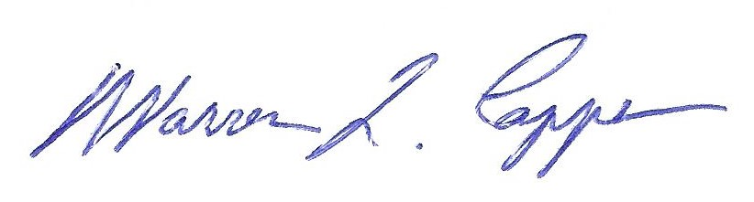

Tim H Graves, Secretary Warren Capps, President

