PHOTOGRAPHERS OF DRIPPING SPRINGS
September 26, 2019 Monthly Meeting Minutes
Location: The Episcopal Church of the Holy Spirit
301 Hays Country Acres Rd

Start time: 6:33 pm

33 people in attendance (33 members; 0 visitors)

PODS President Warren Capps called the meeting to order and reviewed the Agenda and news for the evening:

Agenda
- Calendar
- Celebrations
- Volunteer Opportunities
- Elections
- Reports
- Guest Speaker – Heather Harris, Mixed Media
- Photo Reviews – Water

Calendar
- October 5: Scott Kelby’s Worldwide Photo Walk
  - Starts at 9:30 on Mercer St
  - Great opportunity to recruit new members to PODS
  - No more than 50 can sign up
  - Will be led by Tim Graves
  - www.worldwidephotowalk.com

  - November Meeting
Thursday, November 21, 6:30 pm

- December Holiday Party
Friday, December 13, 6:30 pm

Celebrations
  - Cathy Potwin Jones
2nd Place in Cheese Contest – Fine Art America
Artist of the Week – Fine Art America
- Winifred Simon

Wimberly Valley Art League Show

Volunteer Opportunities (see Warren for details)
2nd Request
- Downs Syndrome Association of Central Texas (DSACT)
- Needs a volunteer photographer for their Buddy Walk
  - October 20, 2019 from 12 pm to 4 pm
  - Details – contact Asha Thomas
    - asha.thomas@dsact.org
    - 512.323-0808 or www.dsact.org/buddy-walk

Elections
November is the month for the biannual election of PODS officers
  - Terms are for 2 years
  - All positions open
  - Nominating Committee
    - Michael Penn Smith
    - Tim Graves
    - Patty Robertson

Reports
- Vice President - Absent
- Field Trip Coordinator – Tim Graves reported on the recent Bullock Museum field trip and added that the October trip would be to the Espada and San Jose Missions in San Antonio. A number folks indicated interest in the trip and preferred a weekday. The November trip will be to the Wild Basin. Greg Cook added that we still have a to-be-timed trip to the Pedernales State Park “Twin Falls” – depending on rains.
- Show – Chris Wuestefeld reportedthat we need to split duties for the show. He’ll continue with the production work but someone needs to take over the “front end” work securing a location and dealing with details related to the location.
- Programs – Nancy Hernandez reported that PODSTER Tom Hausler will provide our October meeting program regarding his recent trip to Egypt.
- Workshops – Patty Robertson– no update
- Public Relations/Social Media – Michael Penn Smith– no update
- Membership – Dee Kasberger - no update
- Tom Delaney – Reviews– no update

Our Guest Speaker - Heather Harris provided an overview of her career and discussion of her work as a “mixed media” artist.

Photo Reviews – Water
Tom Delaney led the group through a review of member photographs reflecting this month’s theme - WATER.

Next month’s theme = “MUSICAL”

The meeting ended at approximately 8:10pm.

Submitted Approved
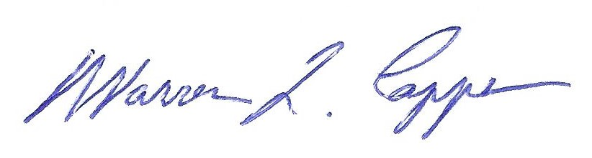

Tim H Graves, Secretary Warren Capps, President

