PHOTOGRAPHERS OF DRIPPING SPRINGS
August 22, 2019 Monthly Meeting Minutes
Location: The Episcopal Church of the Holy Spirit
301 Hays Country Acres Rd

Start time: 6:33 pm

45 people in attendance (40 members; 5 visitors)

PODS President Warren Capps was absent so PODS Vice-President Doug Gephardt called the meeting to order and reviewed the agenda and news for the evening:

Agenda
- Calendar
- Reports
- Guest Speaker – David Valdez
- Photo Reviews – Hot!!

Welcome New Member
- Romero de la Cruz

Calendar
- September 26: Monthly Meeting – speaker Heather Harris
- October 5: Scott Kelby’s Worldwide Photo Walk
  - Need one or two people to volunteer to lead
  - Great opportunity to recruit new members to PODS
  - A lot of fun!
  - Only 50 people or less can sign up

Celebrations
PODS members recognized in our Minimalism Show
Chris Wuestefeld – Best in Show for Beach Geometry
Patty Robertson – 1st Place for Step Up and Into
Nancy Hernandez – 2nd place for Magenta Window Box
Warren Capps – 3rd place for Terra Cotta

But wait, there’s more
Both Tom Hausler and Chris Wuestefeld sold photos at the show

And finally, Cathy Potwin Jones - 3rd place in the Tree Close-up Contest on Fine Art America!

Volunteer Opportunities
- Downs Syndrome Association of Central Texas (DSACT)
- Needs a volunteer photographer for their Buddy Walk
  - October 20, 2019 from 12 pm to 4 pm
  - Details – contact Asha Thomas
    - asha.thomas@dsact.org
512.323-0808

Thanks
- To all the hard workers who helped make this show a success, especially
Chris Wuestefeld and Patty Robertson

Vacancies
- Treasurer
  - Is normally an elected officer position
    - Next 2 year term starts January 1
  - Will be appointed to fulfill remainder of this term
  - Duties
    - Shall have charge of all moneys of PODS
    - Shall pay all bills and shall keep an itemized record, including the two preceding years in a permanent file of receipts and expenditures
    - Shall prepare an annual financial report and budget for the coming year
    - Shall prepare periodic updates of the financial reports and budget when requested by the President
  - If someone is interested in the position, please contact our President President Capps.

Reports
- Vice President – Doug Gephardt discussed the two Lightroom workshops he has conducted for the club. A third workshop covering workflow, troubleshooting, and general Q&A will be held in mid to late September

- Field Trip Coordinator – Tim Graves discussed the Bat Cruise and upcoming field trips that will be finalized soon:

September – Bullock Museum
October – San Antonio Missions
November – Wild Basin
TBD - When the rains cooperate – hike up-river from the main Fallson the Pedernales River

- Activities – Winifred Simon referred everyone to the PODS website regarding the multitude of Central Texas, photo-worthy activities coming up in the Fall

- Show – Chris Wuestefeld thanked everyone for their help in putting on our show at Sky Cinema and asked everyone to take their show photos home

- Programs – Nancy Hernandez discussed upcoming monthly meeting programs featuring Timothy Sens and Sean Thomas

- Workshops – Patty Robertson thanked Doug for his work on the LightRoom workshops and announced that PODS member Jerry Moreno is developing a Workshop on “Astral Photography” for October

- Public Relations/Social Media – Michael Penn Smithgave his reporting time back to the group

- Membership – Dee Kasberger let everyone know that she has new “Member Packets” available for use – please see her regarding membership and club information

- Tom Delaney – Reviews (See below)

Almost Annual Bat Cruise
- Most well attended Bat Cruise ever
  - 39 members, family, and friends
  - Bats and the Setting Sun put on a great show – the Moon will make a guest appearance next time …

Our Guest Speaker
Nancy Henderson and Linda Nickell introduced our Guest Speaker, David Valdez.

David is one of 11 Presidential Photographers in our nation’s history. He worked with George H W Bush when he served as Vice-President and as our 41st US President.

David provided a fascinating discussion about how he became Bush’s photographer. He then provided a slide show of his work as well as “insider info” such as:
- He shot 65,000 rolls of film during his work with President Bush
- He once jumped in the ocean at Kennebunkport while the amused President high-tailed it back to the house
- Russian President Gorbachev didn’t “cotton much” to the game of horseshoes

He ended his presentation with information on his current work with Disney Productions and AMTRAK and some ideas for the club concerning upcoming events around central Texas.

Photo Reviews – HOT HOTHOT
Tom Delaney led the group through a review of member photographs reflecting this month’s theme –HOT X 3.

Next month’s theme = WATER

The meeting ended at approximately 8:09pm.

Submitted Approved
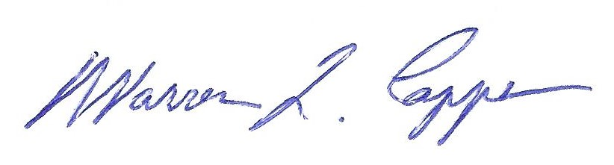

Tim H Graves, Secretary Warren Capps, President

