PHOTOGRAPHERS OF DRIPPING SPRINGS
July 25, 2019 Monthly Meeting Minutes
Location: The Episcopal Church of the Holy Spirit
301 Hays Country Acres Rd

Start time: 6:33 pm

31 people in attendance (29 members; 2 visitors)

PODS President Warren Capps called the meeting to order and reviewed the Agenda and news for the evening:

Agenda

- Calendar
- Reports
- Guest Speaker – Tamra Green
- Photo Reviews – Old, Ancient, Elderly, Aged

Welcome New Members

- Vince Curletta
- Rich Everhart

Calendar

- August 3: Lightroom Workshop Part 2
  - 9 am to 2 pm
- August 17: Bat Cruise
- August 25: Monthly Meeting – speaker TBA

Celebrations

- Winifred Simon
  - Wimberley Valley Art League Show
- Selectees in HCPC
Shows
  - Naturescapes
  - Red

Volunteer Opportunities (see Warren for details)

- Downs Syndrome Association of Central Texas (DSACT) needs a volunteer photographer for their Buddy Walk
  - October 20, 2019 from 12 pm to 4 pm
  - Details – contact Asha Thomas
    - asha.thomas@dsact.org
    - 512.323-0808

Thanks

To Bob Wilson
    - Taught an Intro to Photography class at the DS Library on July 2, 2019

Vacancies

- Treasurer
  - Is normally an elected officer position
    - Next 2 year term starts January 1
  - Will be appointed to fulfill remainder of this term
  - Duties
    - shall have charge of all moneys of PODS
    - Shall pay all bills and shall keep an itemized record, including the two preceding years in a permanent file of receipts and expenditures
    - Shall prepare an annual financial report and budget for the coming year
    - Shall prepare periodic updates of the financial reports and budget when requested by the President
  - If someone is interested in the position, please see President Capps.

Reports

- Vice President – Absent

- Field Trip Coordinator – Tim Graves reported that the Bat Cruise will be held on Saturday August 17, 2019 – details are posted on the PODS Members’ website. We have a good number of sign-ups and welcome all to join us.
The year’s remaining monthly Field Trips will be announced soon.

- Show – Chris Wuestefeld reminded every one of the Reception on August 1, 2019 at 6:30pm at the Sky Cinema and that we’ll need help at the “take-down” on August 18, 2019. (see below)

- Nametags – John Fierstien let everyone know that the nametags used at our meetings can be recycled.

- Programs – Nancy Hernandez let everyone know that our speaker in August will be David Valdez, the White House photographer for George H W Bush. In September we’ll have Mixed Media expert, Heather Harris. October is still being planned.

- Workshops – Patty Robertson let everyone know that our own Doug Gephardt will provide a “Lightroom II” workshop on August 3 focusing on Lightroom techniques for processing and a “Lightroom III” workshop later in August (I DID NOT GET THE DATE) focusing on advanced techniques and trouble-shooting.

- Public Relations/Social Media – Michael Penn Smith asked that everyone post the PODS MINIMALISM SHOW video, created by Patty Robertson, on their Facebook pages.

- Membership – Dee Kasberger (absent)

- Tom Delaney – Reviews – see below

Almost Annual Bat Cruise

Tim Graves covered details related to the Bat Cruise

- August 17
  - Meet at boat 6:30 pm
  - Capital Cruises – 208 Barton Springs Rd.
  - Cost - $22 each, pay at boat
    - Families welcome

Show Reminders

Chris Wuestefeld and Warren Capps covered details related to the PODS Show

- Show Fees due
- Tonight - Print Delivery
  - If you don’t have your prints with you tonight, talk to Chris
- August 1
  - Show installation (morning)
  - Opening Reception (6:30 pm)
- August 18 – Show Take Down

Our Guest Speaker
- Tamra Green – Precision Camera – “What’s in Tamra’s Bag?”

Tamra discussed the amazing items she keeps in her camera bag when she goes on a shoot. For example, don’t forget:
Small knife
Compass
Fire starter
Bug spray
Camera rain bonnet
Hand warmer
Small tripod
Etc, etc, etc ….

Photo Reviews – Old, Ancient, Elderly, Aged

Tom Delaney led the group through a review of member photographs reflecting this month’s theme - Old, Ancient, Elderly, Aged.

Next month’s theme = “HOT”

The meeting ended at approximately 8:11pm.

Submitted Approved
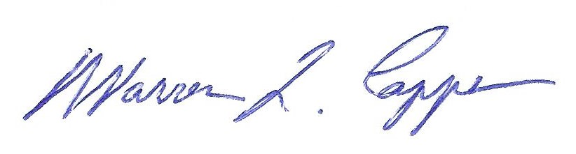

Tim H Graves, Secretary Warren Capps, President

