PHOTOGRAPHERS OF DRIPPING SPRINGS
May 23, 2019 Monthly Meeting Minutes
Location: The Episcopal Church of the Holy Spirit
301 Hays Country Acres Rd

Start time: 6:30 pm

24 people in attendance (22 members, 2 visitors)

Our President, Warren Capps, opened the meeting by reviewing the agenda:

- Calendar
- Celebrations
- Opportunity
- Thanks
- Reports
- On with the Show
- Guest Speaker – Lindsay Hagblom
- Photo Reviews - Mammals

CALENDAR

- May 25: 12–4 pm. Photoshop Basics Workshop by Dave Wilson at DS Library
- June 1: 12–2 pm. Preparing Images for Print and Display Workshop
- June 15: 8:30am – 3:00pm Field Trip to the Pioneer Flight Museum, Kingsbury, TX
- July 25: Monthly Meeting – speaker TBA
- Show Calendar: more later
- August 17: Bat Cruise

RECENT CELEBRATIONS

- Doug Gephart
  - Had several photos acclaimed at the awards program at the Shoal Creek Conservancy Gala
- Winifred Simon
  - Had 2 photos chosen for the Wimberley Valley Art League Show
- Warren Capps
  - Had a photo Accepted for Open Show at Amanda Smith Gallery
- Nancy Fierstien
Had a photo chosen for the Cover of 2020 Texas Poetry Journal

OPPORTUNITY

- PODS CLUB MEMBER Damon Delgado
  - Establishing a lighting store in DS
  - Wants to also sell artwork from local artists
  - Contact: damon@mainplacelighting.com

THANKS

Warren expressed many thanksfor all that contributed to Fotokids – either photo gear or cash

Fotokids raised over $71,000 on May 14

REPORTS
(many chairpersons were absent tending to various international issues)

- Vice President – Doug Gephart, Absent
- Treasurer – Greg Cook, Absent
- Field Trip Coordinator – Tim Graves, Absent
- Programs – Nancy Hernandez, Absent
- Workshops – Patty Robertson
- Public Relations/Social Media – Michael Penn Smith
- Membership – Dee Kasberger, Absent
- Tom Delaney – Reviews
- Show – Chris Wuestefeld (see below)

ON WITH THE SHOW – Chris Wuestefeld and Warren Capps

- All Dates Approximate
  - June 23 – Photo Submissions Due
  - July 7 – Results Announced
  - August 1 - Show Opening and Reception
  - August 18 – Show Teardown
- Judge will be Timothy Sens
  - www.timothysens.com
  - Local photographer that specializes in Minimalism

Warren provided examples and questions to ponder concerning Minimalist Photography:

- Does the image contain only a few distinct colors?
- Does the content and composition guide the viewer to the center of attention?
- Does the "subject" overpower the image?
- Is effective use made of negative space?
- Is the image free of distracting elements?
- Has the rule of thirds been used in composition?
- Is it merely a close-up of a subject? - not minimalism

GUEST SPEAKER

PODS Club member Lindsay Hagblom provided a very insightful and entertaining presentation on portrait photography.

Lindsay’s photography is a celebration of human nature, focused on helping her subject's soul to shine through their eyes. A taste of her empathetic approach:

"How best to photograph you, how to help you smile your honest smile, and forget about my camera.
I've met your "crazy family" and I know you "aren't photogenic.
So, here's what I have to say about you.
You're beautiful.
Yep, you.
And I want to see more of that beauty in my world.
I need it. (selfish)
Then I want to give it back to you, so you can see it too. The real you."
www.lindsayhagblomphotography.com

CLUB MEMBER PHOTO REVIEWS –Tom Delaney led the group in the review of Mammal photographs taken by the club members.

The meeting ended at approximately 7:58pm.

Submitted Approved
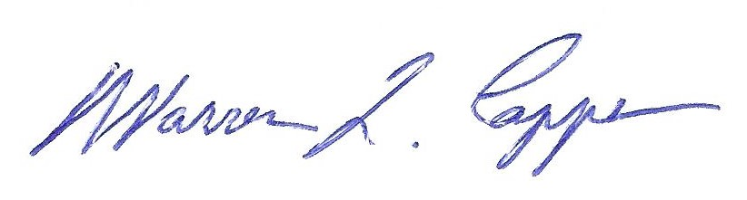
Timothy Graves, Secretary Warren Capps, President

