PHOTOGRAPHERS OF DRIPPING SPRINGS
March 28, 2019 Monthly Meeting Minutes
Location: The Episcopal Church of the Holy Spirit
301 Hays Country Acres Rd

Start time: 6:36 pm

33 people in attendance (30 members; 3 visitors)

President Warren Capps
Final notice that Google Plus is phasing out and PODS will stop using it at the end of March this year. Warren has begun using “Mail Chimp” as a general notice system for the club. It appears to be working and its use will be expanding.

Calendar - Warren reviewed club and other photo events coming up in 2019.

Art Arizipe – discussed the Naturescapes photography competition and exhibition - reviewed 15 year history. Includes people and pets in their natural environment. Deadline is the end of June, submissions open in early April.

PODS Events
- April 17 Pedernales Twin Falls field trip (may change depending on rainfall)
- May 25 Photoshop Dave Wilson
- August 17 Bat, Full Mooon, Sunset Cruise – Lady Bird Lake

Reports
- Doug – discussed photography software updates and Lume Cubes
- Nancy - upcoming speakers - special tour in San Antonio of Keith Carter 50 Years exhibit, May 4 (see facebook)
- Patty - Instagram, Photoshop workshops, coming up.
- No others presented

Keynote Speaker – Antics in Antarctica by our President Warren Capps

Lightroom lessons learned:

- Straighten and Crop first (free form of what looks best to you, then crop for output)
- Global edits - high emphasis on tone curve INSTEAD of basic panel, fiddle with white then black then look for spikes in graph and drag those around.
- Local edits.

The meeting ended at approximately 8:10pm.

Submitted Approved
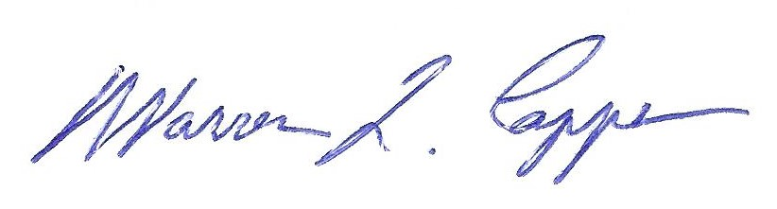
Timothy Graves, Secretary Warren Capps, President

