PHOTOGRAPHERS OF DRIPPING SPRINGS
April 25, 2019 Monthly Meeting Minutes
Location: The Episcopal Church of the Holy Spirit
301 Hays Country Acres Rd

Start time: 6:36 pm

37 people in attendance (34 members; 3 visitors)

President Warren Capps
Calendar - Warren highlightedsevencluband other photo events coming up in 2019.

- April 27 – 12 - 2 pm. Instagram Workshop by Linda Nickell, Dripping Springs Community Library
- May 4 – Keith Carter Field Trip
- May 22 or 23 – Architecture Field Trip, UT Blanton Museum and South Campus
- May 23 – Monthly Meeting – Lindsay Hagbloom on Portraiture
- May 25 – 12-4 pm. Intro to Photoshop by Dave Wilson at DS Library
- August 17 – Bat Cruise

Social Media Review –
Total Members – 57
Total Members on Facebook – 54
Total Members on MailChimp - 57

Reports
Chris Wuestefeld reported that the location of the PODS Spring Show is still under development. He and Warren asked for ideas from the group – Tom Delaney and Jen Kuykendall discussed possibilities at the Bee Caves Galleria.
NOTE: On April 28, Chris let folks know that Patty Robertson has visited with the GM of the Sky Cinema and he has agreed to have the PODS “Spring” show this summer. Details to follow.

Warren let everyone know that he will miss the June PODS meeting. He will be in Guatemala teaching a photo class for Mayan children – his 11th trip there. He asked that if folks had photography equipment they could donate to the effort that would be greatly appreciated. Financial contributions are also welcome.

VP Doug Gephardt discussed three items:
  - “Luminar 3.1” is now available and free for subscribers
  - “On One Photo” update will be available in mid-May
  - The “Out-of-Chicago” conference is in late June and a good learning and networking occasion. Street and architecture shooting, in and around the city, has been one of the excellent workshops at the conference and is offered again this year.

- Field Trip Coordinator Tim Graves provided an update on the April 17 club trip to two Austin Museums (Laguna Gloria and Elisabet Ney). He discussed the next trip in May focused on Architecture at and around the University of Texas Blanton Museum, the “Austin” building, and the south mall of the UT campus. Notice on timing and details will be posted soon – the trip will likely be on May 23. The “Bat Cruise” will be on August 17, rain or shine.

- Program Coordinator Nancy Hernandez discussed the special May 4 PODS visit to the Witliff Collections in San Marcos. The Keith Carter collection is the focus of the trip and PODS attendees will receive a curator tour of the exhibition.

- Workshop Coordinator Patty Yznaga Robertson discussed upcoming workshops: The Instagram Workshop (April 27)and the Photoshop Workshop lead by Dave Wilson (May 25).
As part of the Workshop discussion, Lindsay Hagbloom offered to develop a workshop on “Natural Light Portraiture”. Doug Gephardt also offered to develop two “Lightroom” workshops in the near future. Jerry Moreno offered to help with a workshop on “Night Photography” and Michael Penn Smith was cajoled into discussing a “Landscape Photography” workshop.

NOTE: Updates on all PODS events can be found at the PODS member webpage – photographersofds.us

Thanks
Warren, on behalf of PODS, thanked:
Jerry Moreno for his volunteering to take photos of the staff at the Westcave Preserve, and
Bob Wilson for his volunteer work with the Dripping Springs Summer Photo Class

Program
Nancy Hernandez introduced Amanda Smith & Kevin Tulley, co-owners of the the A. Smith Gallery in Johnson City. Both have been in the photography business for many years and they discussed the history and operations of their Gallery in Johnson City.

They have been good and long-time friends of PODS and provided an insightful overview of the opportunities for photographers at the Gallery ranging from exhibitions, workshops, etc. More information about the Gallery can be found at: asmithgallery.com

Photo Reviews
Tom Delaney hosted the review and discussion of seven photos submitted by PODS members. The April topic was “Building(s)”. The May topic will be “Mammals”.

The meeting ended at approximately 7:58pm.

Submitted Approved
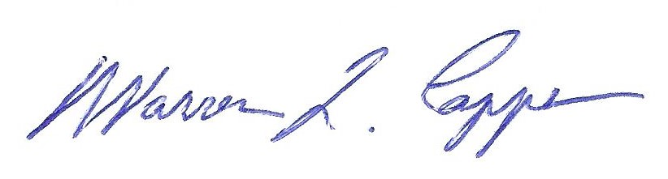
Timothy Graves, Secretary Warren Capps, President

