PHOTOGRAPHERS OF DRIPPING SPRINGS
January 24, 2019 Monthly Meeting Minutes
Location: The Episcopal Church of the Holy Spirit
301 Hays Country Acres Rd

Start time: 6:32 pm

33 people in attendance (28 members; 5 visitors)

President Warren Capps
Google Plus is phasing out and PODS will stop using it at the end of March this year. We are exploring the use of “Mail Chimp” as a general email noticification system for the club.

Membership Committee Chair Phyllis Rummel has resigned. Warren and the club recognized Phyllis’ good work for the club as one of its founding members and for her continuous efforts to expand and improve the club’s membership and activities. In recognition, the club has granted Phyllis membership for 2019 at no cost.
Warren asked for a volunteer to take over the committee’s chair position.

Photo review – we are starting a new element for the monthly meetings. Although under construction, the idea is to provide at the end of each monthly meeting a time for the Review/Critique of members’ photographs. Tom Delaney will coordinate the effort each month and collect photos prior to our meetings. Warren pointed out that this effort will add 15-30 minutes to our monthly meetings, but everyone thought that’s OK and it’s worth a try.

Dripping Springs Chamber of Commerce – needs one or two photographers for its Star Awards program on February 7. Warren asked for volunteers.

Celebration of Awards and Recognition - Several PODS members have received awards or have been recognized for their photography work in the past couple of months:
Winifred Simon, Patty Yznaga Robertson, Tom Hausler, Dave Wilson, Drew Wilson, and David Wilson were congratulated and received resounding applause from the group.

2019 Budget – Warren presented the elements of the club’s budget for 2019. The budget does not increase dues and provides for annual bottom line expenses of $2,350. The budget assumes a small increase in membership, funds for speaker expenses, advertising on Facebook, and maintenance of routine club activities. An estimated balance of $800 would be carried over to 2020. The budget proposal was approved by unanimous acclamation.

Vice President - Doug Gephardt
Discussed some new software options and updates.

Treasurer - Greg Cook
Thanked everyone for the 2019 budget approval and reminded those assembled that dues for 2019 are now due. Payment can be made on the PODS website: www.photographersofds.com.

Activities Guru - Winifred Simon
Handed out a list of sixteen possible photo-worthy activities around DS during January, February, and March 2019.

Field Trips Coordinator – Tim Graves
Handed out a draft list of club Field Trips for January thru May 2019. During discussion, a conflict was noted for the Schulenberg Painted Churches trip and a PODS Workshop on February 23. Tim said that conflict would be corrected and the results posted on the PODS social media sites.

Program Coordinator – Nancy Hernandez
Nancy provided info on meeting programs including a “Bamberger Selah Ranch” presentation in February, an “Antics in Antarctica” presentation by our own Warren Capps in March, and “Gallery Business” by A Smith in April. Send ideas to Nancy at: nhernandez2604@gmail.com.

Workshop Coordinator – Patty Yzanaga Robertson
Presented plans for a February 23 workshop on “Photographers Uses of Instagram”, a possible workshop on “Alternatives to Adobe”, and a possible “Photo Critique” workshop for PODS members. Details to follow on PODS social media.

PR/Social Media Coordinator – Michael Penn Smith
Discussed the new Facebook group for PODS and how the club is working to maximize our community reach out.

PODS Show Coordinator – Chris Wuestefeld
Discussed that the club’s Winter/Spring show would likely be at the Sky Cinema in Belterra and the theme will be “minimalism” - details soon.

PROGRAM
Bella Muntz Kirchner, local Austin photographer, made a slideshow presentation entitled “Seeing the Everyday in a New Light”. The program focused on the use of IPhone and SLR cameras to capture small and momentous things happening around us in an almost constant fashion.

PODS Photo Review Coordinator – Tom Delaney
Lead the group in the viewing of 14 photos from club members, with those present explaining what they liked about the photo chosen.

The meeting ended at approximately 8:25pm.

Submitted Approved
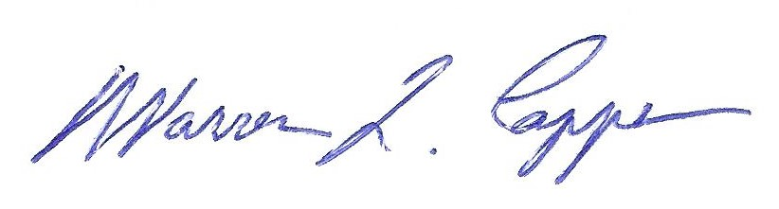
Timothy Graves, Secretary Warren Capps, President

