Planning for the Unexpected in Travel Photography
This will be a 3 part series of articles on travel photography. Article 1 will discuss what you hope to do with your photographs. Article 2 discusses how to physically prepare a travel photography journey. Article 3 will discuss preparation before the trip and how to be mentally ready for what comes your way during the trip.

What will you do with your photos after you get back?
I love travel photography. It is probably my most favorite passion, combining my love of seeing new places along with recording what I see with a camera. I have taken a couple of dozen photo workshops and tours. I have been to over 30 countries and 49 states (Hawaii is coming up this fall). Along the way, I have picked up a few practices that I think many would find useful. If not, in this day and age, I am sure you will let me know.
When I first started thinking of this topic, I thought I would simply talk about the physical and mental preparation that you might want to do to take outstanding photos during a trip. But the more I explored the topic, the more I realized that the last must be first. The very first question you must ask yourself is “What do I want to do with these photos when I get home?”. The answer to that question will greatly influence what you shoot and how/when you shoot it.
So, you have taken that great trip of a lifetime and have come home with 5000 photos. What are you going to do with them? For a friend of mine, the act of taking them seems to be enough. She almost never goes back and reviews the photos after a trip. She would also be the first to tell you that she is not a “real” photographer. But let’s suppose you want to share your photos. Let’s talk about how you might do that.
Are you an obsessive documenter? Do you want to be able to record all the documentary information about the photos you take? Trust me, it takes quite a bit of extra time to record what or who you photographed. It means that you will find yourself taking photos of signs as memory aids.
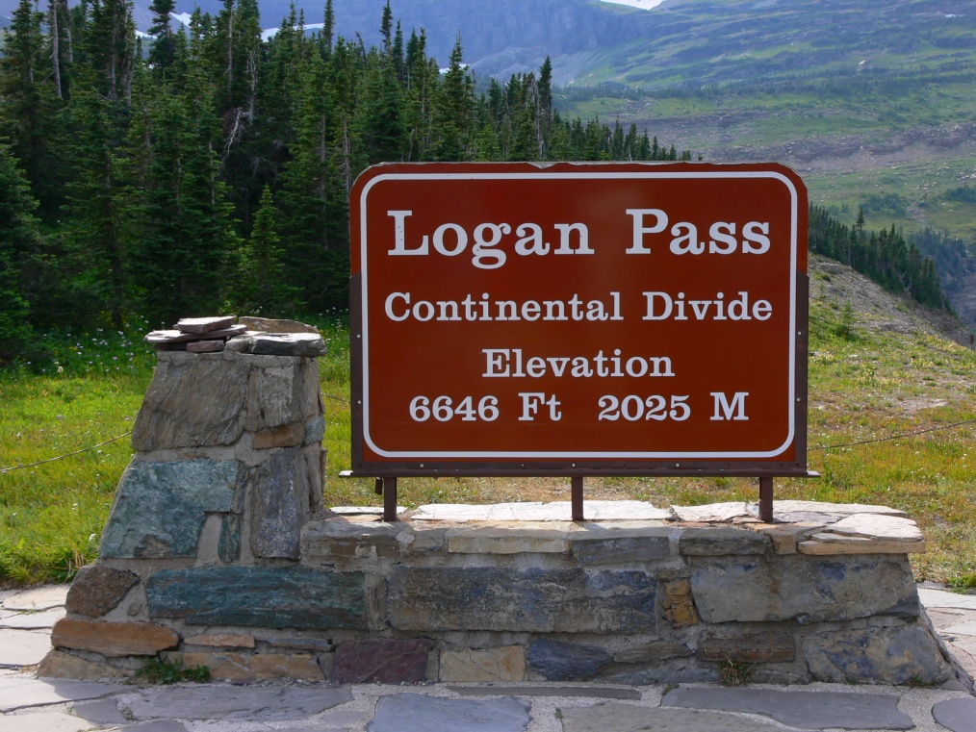
Many of our cameras still lack in-camera GPS, so if we don’t document, we might not even know where we took the photos. And oops, did you forget to set your camera’s clock to local time? This one is a biggie. Always set you camera to local time! And set it back when you get home. Otherwise, you might not have a good idea of when you shot the photo.
Another good reason to document is if you plan to return to the area or sell your photos as stock. I have a semi-professional friend that has been going to Oaxaca, Mexico for decades. She documents everything she shoots and brings back photo prints every year to the people she shot the year before. As a result, she has built strong relationships with the locals and gets invited to many events and homes that the standard tourist would never see.
Do you want to share your photos on social media and/or the internet? This is perhaps one of the most popular methods of sharing photography. Facebook, Instagram, Flickr, Snapchat, 500px, Photobucket, Smugmug, Google Photos, etc. all offer a number of ways to edit, store, display and share your photography, many at little or no cost. Do you have your own website, your own blog that you want to shoot and write for? If so, you may have an idea that needs illustrating.
Do you want to print your photos when you get home? I have lots of my photographs up on walls, mostly in my office. They sneak out in to other areas of the home when my wife isn’t looking. Some folks print out 4x6 photos simply so they can share them with family and friends that are not computer savvy.
Do you like to see you photos on mugs, create calendars of them, or make souvenir or coffee table books? One of my mom’s favorite gifts is a mug with my mug on it. Calendars are wonderful gifts at Christmas time that document your travels. I have one friend that loves to use Shutterfly to create a small book of her trips and another that produces a pretty good size coffee table book of his travels.
Do you like to assemble your photos into a video, creating a travelogue of you trip? Lightroom, Photodex, and other software offer great capabilities in creating slide shows complete with text, transitions, and music. You can post the resulting videos on Facebook, your own website or send them to your friends as DVDs. Here is a simple example of a trip to Morocco: https://www.youtube.com/watch?v=gsxo5V-8m-o.
And here is a little secret. Photos used in slide shows do not need to be perfect. Many times, a photo is on the screen for only a second or two. It really doesn’t have to be perfectly in focus or perfectly exposed. When creating a slide show, you are building emotional content.
Do you want to enter your photographs in contests? Contests are a great way to measure your skills against others. However, be very careful and understand the rules. In some cases, you will be giving away all rights to your photos.
Do you want to list your photos on stock sights for sale? Adobe Stock and Shutter Stock are a couple of sites that come to mind. This is a nice way to make back a little bit of money to finance your next photography purchase. Again, I have a friend that has sold a photo of Bran Castle (Dracula’s Castle) in Romania a couple of hundred times. Granted, she gets only a quarter every time she sells it, but it does add up. However, understand two things. These sites want very solid documentation of what you shot (think keyword searches) and if you have people in them, they may want model releases.
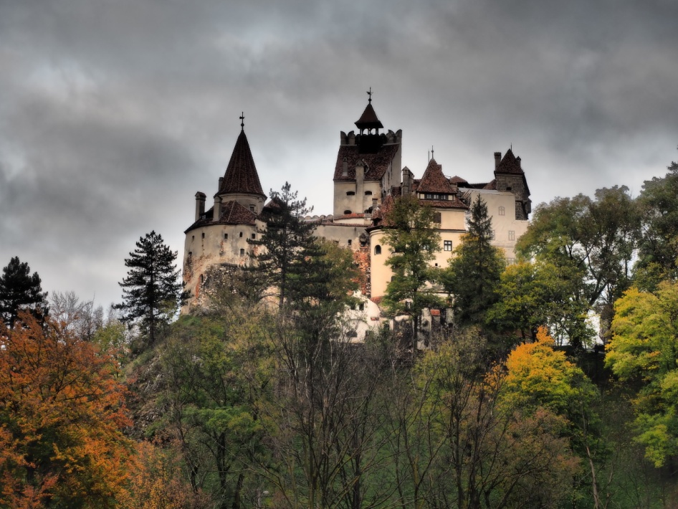

Your choices of what you want to do with your photography will influence what you shoot and what you keep. For example, everybody loves a picture of themselves. You might concentrate on taking photos of your companions so that you can share them in myriad ways. I have been on photo tours where a grandfather took a favorite doll of a grandchild and photographed in every location we visited. A sweet way to document the trip and maybe instill a love of travel into a child.
Whatever you do, enjoy what you are doing. Travel is a way of opening up, learning new cultures, and communicating in new ways. Many times a camera can a means to starting a dialog with someone. If you are like me, it is easy to become addicted.

